**EXPERIMENT 12:**

Write the python program for Tic Tac Toe game.

**AIM:**

The aim is to solve the tic tac toe game using python program.

**PROGRAM:**

def print_board(board):

for row in board:

print(" ".join(row))

def check_win(board):

for row in board:

if row.count(row[0]) == len(row) and row[0] != ' ':

return True

for col in range(len(board)):

check = []

for row in board:

check.append(row[col])

if check.count(check[0]) == len(check) and check[0] != ' ':

return True

if board[0][0] == board[1][1] == board[2][2] != ' ':

return True

if board[0][2] == board[1][1] == board[2][0] != ' ':

return True

return False

def tic_tac_toe():

board = [[' ' for _ in range(3)] for _ in range(3)]

print_board(board)

player = 'X'

while True:

print(f"Player {player}, enter your move: ")

move = input()

x, y = map(int, move.split())

if board[x][y] != ' ':

print("Invalid move, try again.")

continue

board[x][y] = player

print_board(board)

if check_win(board):

print(f"Player {player} wins!")

break

player = 'O' if player == 'X' else 'X'

tic_tac_toe()

**INPUT:**

Player X enter your move:

Player Y enter your move:

**OUTPUT:**

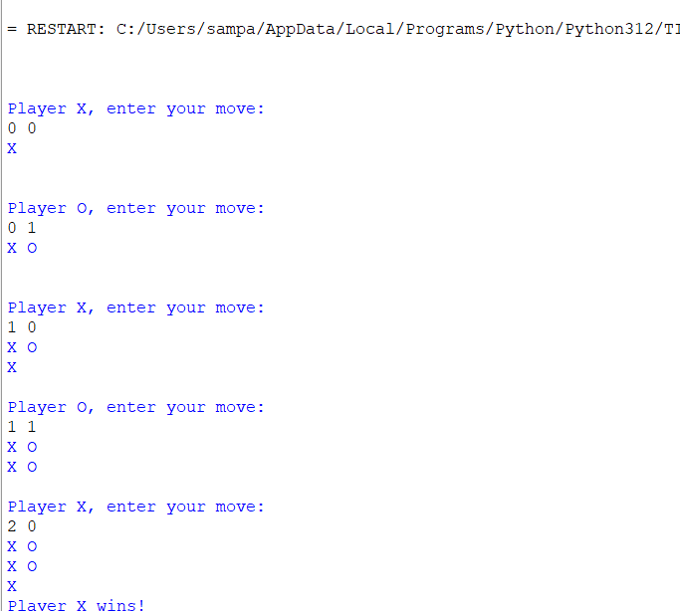

**RESULT:**

The tic tac toe game is executed successfully.